**Write a program to check Whether Two Strings are Anagrams or not.**

#include <stdio.h>

#include <string.h>

#include <ctype.h>

int areAnagrams(char str1[], char str2[]) {

int count[256] = {0};

if (strlen(str1) != strlen(str2))

return 0;

for (int i = 0; str1[i] != '\0'; i++) {

count[tolower(str1[i])]++;

}

for (int i = 0; str2[i] != '\0'; i++) {

count[tolower(str2[i])]--;

}

for (int i = 0; i < 256; i++) {

if (count[i] != 0)

return 0;

}

return 1;

}

int main() {

char str1[100], str2[100];

printf("Enter first string: ");

scanf("%s", str1);

printf("Enter second string: ");

scanf("%s", str2);

if (areAnagrams(str1, str2))

printf("The strings are anagrams.\n");

else

printf("The strings are not anagrams.\n");

return 0;

}

**Output:**



**Write a program to find sum of digits using recursion.**

**#include <stdio.h>**

**int sumOfDigits(int n) {**

**if (n == 0)**

**return 0;**

**return (n % 10) + sumOfDigits(n / 10);**

**}**

**int main() {**

**int number;**

**printf("Enter a number: ");**

**scanf("%d", &number);**

**int sum = sumOfDigits(number);**

**printf("Sum of digits of %d is %d\n", number, sum);**

**return 0;**

**}**

**Output:**

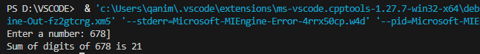

**Write a program and a function to swap two numbers using call by reference.**

**#include <stdio.h>**

**void swap(int *a, int *b) {**

**int temp;**

**temp = *a;**

**\*a = *b;**

**\*b = temp;**

**}**

**int main() {**

**int x, y;**

**printf("Enter two numbers: ");**

**scanf("%d %d", &x, &y);**

**printf("Before swapping: x = %d, y = %d\n", x, y);**

**swap(&x, &y);**

**printf("After swapping: x = %d, y = %d\n", x, y);**

**return 0;**

**}**

**Output:**

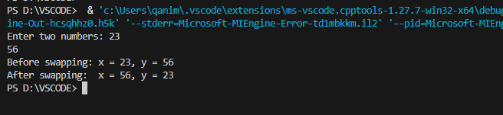

**Write a function to sort an array using functions.**

**#include <stdio.h>**

**void sortArray(int arr[], int n) {**

**int i, j, temp;**

**for (i = 0; i < n ; i++) {**

**for (j = i+1; j < n ; j++) {**

**if (arr[i] > arr[j]) {**

**temp = arr[i];**

**arr[i] = arr[j];**

**arr[j] = temp;**

**}**

**}**

**}**

**}**

**void printArray(int arr[], int n) {**

**for (int i = 0; i < n; i++) {**

**printf("%d ", arr[i]);**

**}**

**printf("\n");**

**}**

**int main() {**

**int arr[100], n;**

**printf("Enter number of elements: ");**

**scanf("%d", &n);**

**printf("Enter %d elements:\n", n);**

**for (int i = 0; i < n; i++) {**

**scanf("%d", &arr[i]);**

**}**

**printf("\nOriginal array: ");**

**printArray(arr, n);**

**sortArray(arr, n);**

**printf("Sorted array: ");**

**printArray(arr, n);**

**return 0;**

**}**

**Output:**

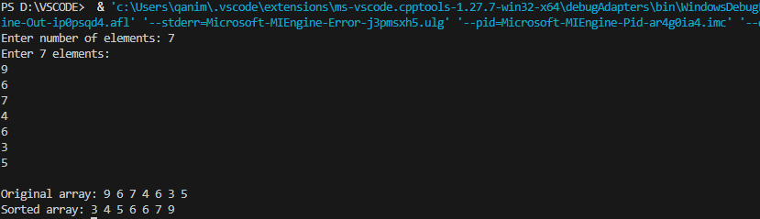

**Write a program to define a structure name student with roll number, name, and marks.**

**Write functions to input and display student details.**

**#include <stdio.h>**

**struct Student {**

**int rollNumber;**

**char name[50];**

**float marks;**

**};**

**void inputStudent(struct Student *s) {**

**printf("Enter roll number: ");**

**scanf("%d", &s->rollNumber);**

**printf("Enter name: ");**

**scanf(" %[^\n]s", &s->name);**

**printf("Enter marks: ");**

**scanf("%f", &s->marks);**

**}**

**void displayStudent(struct Student s) {**

**printf("\nStudent Details:\n");**

**printf("Roll Number: %d\n", s.rollNumber);**

**printf("Name: %s\n", s.name);**

**printf("Marks: %.2f\n", s.marks);**

**}**

**int main() {**

**struct Student s;**

**inputStudent(&s);**

**displayStudent(s);**

**return 0;**

**}**

**Output:**

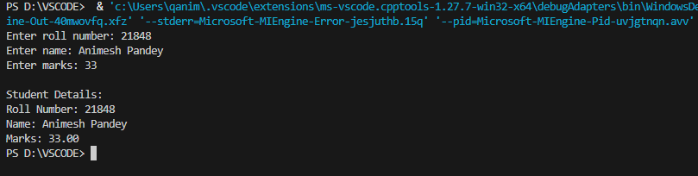

**Write a program to create a structure employee (ID, Name, Basic Pay, DA, HRA, Gross Salary).**

**and write a function to calculate salary and display details.**

**#include <stdio.h>**

**struct Employee {**

**int ID;**

**char name[50];**

**float basicPay;**

**float DA;**

**float HRA;**

**float grossSalary;**

**};**

**void calculateSalary(struct Employee *e) {**

**e->DA = 0.1 * e->basicPay;**

**e->HRA = 0.05 * e->basicPay;**

**e->grossSalary = e->basicPay + e->DA + e->HRA;**

**}**

**void inputEmployee(struct Employee *e) {**

**printf("Enter Employee ID: ");**

**scanf("%d", &e->ID);**

**printf("Enter Employee Name: ");**

**scanf(" %s", e->name);**

**printf("Enter Basic Pay: ");**

**scanf("%f", &e->basicPay);**

**calculateSalary(e);**

**}**

**void displayEmployee(struct Employee e) {**

**printf("\nEmployee Details:\n");**

**printf("ID: %d\n", e.ID);**

**printf("Name: %s\n", e.name);**

**printf("Basic Pay: %.2f\n", e.basicPay);**

**printf("DA: %.2f\n", e.DA);**

**printf("HRA: %.2f\n", e.HRA);**

**printf("Gross Salary: %.2f\n", e.grossSalary);**

**}**

**int main() {**

**struct Employee e;**

**inputEmployee(&e);**

**displayEmployee(e);**

**return 0;**

**}**

**Output:**

